For training purpose we used Visual Studio. ML.NET Model Builder provides an easy to understand visual interface to build, train, and deploy custom machine learning models. Prior machine learning expertise is not required. Model Builder supports AutoML, which automatically explores different machine learning algorithms and settings to find the one that best suits the scenario.

1. Starting with the selection of the scenario, in our scenario it is image classification problem.

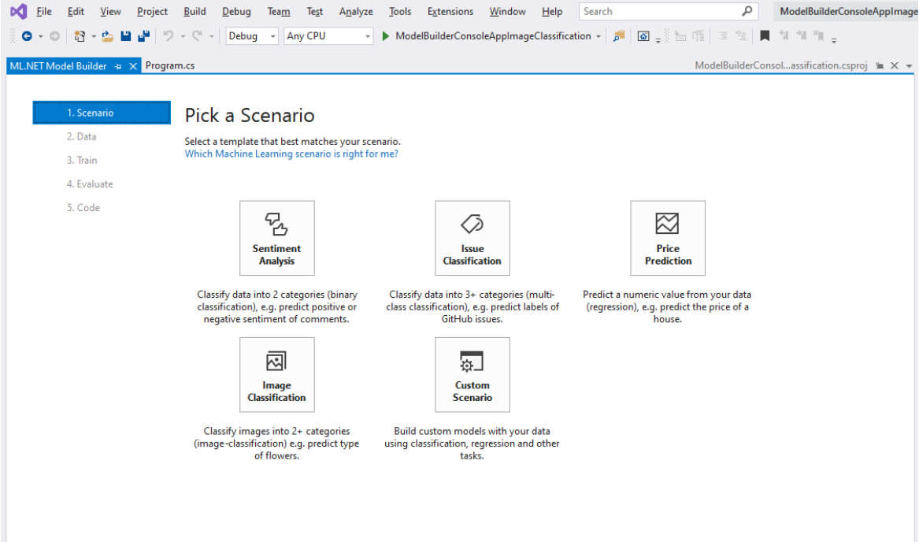

1. And then selecting a folder with the Images.

Model Builder expects image data to be JPG or PNG files organized in folders that correspond to the categories of the classification.

To load images into Model Builder, provide the path to a single top-level directory:

* Top-level directory contains one subfolder for each of the categories to predict.
* Each subfolder contains the image files belonging to its category.

1. And now we start the training process.

We created 350 image dataset for each step ,and there were 8 such steps. Approximate time required for training the model was 4.5 hrs.

1. In evaluation step we provided our sample input images and tested the acuuracy of the model.

